Student names: Akansobe Adeline, Buszta Claudia, Godwin Denys, Li Binghui

Course: GEOG 397

**Mapping rooftop photovoltaic panels and assessing the suitability of building rooftops for photovoltaic installation in Worcester, MA.**

**1. Introduction**

In response to the global imperative to combat climate change, governments are actively reshaping energy policies to transition from conventional fossil fuels to cleaner and renewable sources. This paradigm shift has sparked remarkable progress in sustainable technologies. Studies by Shivanshu (2020) reveal that 8-10% of the world's energy is now sourced from renewables, underscoring the tangible impact of these transformative energy policies. Additionally, research from Gawley et al. (2022) emphasizes that this transition not only aligns with environmental goals but is intricately connected to multiple socio-economic benefits, including improved air quality, reduced energy costs, and enhanced energy security.

Renewable energy manifests in various forms, encompassing wind power, solar power, bioenergy, hydroelectric, and tidal energy. Notably, among these sources, solar farms and rooftop solar energy applications stand out, surpassing others in current and future potential (Shivanshu, 2020). Urban areas, recognizing the profound benefits of harnessing solar energy, are increasingly turning to rooftop installations. This surge is attributed to their capacity to diminish reliance on conventional energy sources and alleviate environmental impacts. However, the efficacy of these installations hinges on the suitability of building rooftops, considering factors such as tree canopy, slope of these buildings. These aspects, often overlooked in traditional assessments, play a pivotal role in determining the feasibility and efficiency of solar panels in urban settings.

The use of multispectral satellite imagery to identify ground solar photovoltaic has been demonstrated in recent literature using a combination of Random Forest and unsupervised clustering methods (Tao et al, 2023). Previous literature is focused on identifying larger ground solar installations and relating these to patterns of development and land use change. We adapted existing methodologies from Tao et al. to higher resolution datasets in order to locate solar panels, analyzed their suitability using tools and methods adapted from Gawley et al. (2022) and assessed potential impacts and patterns of rooftop solar adoption. The project used Worcester as a feasibility study with the potential for scaling up to broader regions if the analysis yields useful results. The data used are: 300 rooftop panels, MassGIS 2019 Ortho aerial imagery, MassGIS 2021 Ortho aerial imagery, building footprints, tree canopy data, Light Detection and Ranging (lidar) datasets where Digital Elevation Models (DSM) was derived and used to generate the Solar radiation for each predicted solar rooftop in both years.

1.1 Objectives

* Accurately map the photovoltaic rooftop power which includes their locations, shapes, and extent as of 2019 and 2021 in Worcester, Massachusetts.
* Develop a comprehensive Multicriteria Evaluation (MCE) model that considers building footprints, tree canopy coverage, and LiDAR data to evaluate rooftop solar suitability.
* Assess the solar energy potential of identified rooftops and understand the impact on local tree canopy.

1.2 Research Questions

Our project addressed the following research questions:

1. What is the electricity capacity of rooftop solar photovoltaic generation in Worcester, MA?
2. What is the rate of change for the total area of solar in Worcester, MA?
3. Are there any spatial patterns of the distribution of solar panels not related to demographics in Worcester, MA?
4. Do areas with new solar panels (added between 2019 and 202l) show evidence of trees being cut down for installation (change in tree canopy cover)?

**2. Methodology**

2.1. Identifying Rooftop Solar Panels

The solar panel training dataset was hand-digitized using 2019 orthorectified aerial imagery which was accessed from the MassGIS website [https://www.mass.gov/](https://www.mass.gov/info-details/massgis-data-2019-aerial-imagery) (accessed on 17 October 2023). These training dataset were exported to Region-Based Convolutional Neural Network (RCNN) machine learning based on 2019 orthorectified aerial imagery, with solar polygons as target feature boundaries. The pre-trained RCNN is fine-tuned for 100 epochs, using the fine tuning dataset from step 2. The trained model was then used to identify solar panels in Worcester in 2019 using the 2019 orthophotos imagery. The predicted solar panel polygons were filtered based on three conditions; polygons which intersected building footprints from the Massachusetts Building Footprint dataset, those with a confidence greater than 65 and an area greater than 2 square meters. These polygons are squared off using Regularize Building Footprints, and finally checked manually against 2019 orthophotos. False alarms were removed. Examples of these automatically generated solar polygons are found in Figure 1 in Appendix B.

A similar process was conducted for 2021, using the fine-tuned RCNN for inference on the 2021 orthophotos dataset. However for the 2021 filtering of the predicted solar panels, a different criteria was based on a confidence threshold greater than 80 and an area greater than 2 square meters. This difference confidence threshold was chosen due to the difference in sun azimuth causing many false positives between 65 and 80 percent model confidence.

In order to create solar panel data for 2015, solar panel polygons from 2019 were manually checked against orthophotos for 2014, with the assumption that there are minimal rooftop solar panels from 2015 that were removed in the next 4 years. 128 solar panel polygons were identified using this methodology.

2.2. Analysis of Solar Power Potential

The LiDAR dataset was accessed from USGS website [https://rockyweb.usgs.gov/](https://rockyweb.usgs.gov/vdelivery/Datasets/Staged/Elevation/LPC/Projects/MA_CentralEastern_2021_B21/MA_CentralEastern_1_2021/LAZ/) (accessed on 20 December 2023) and converted into a raster Digital Surface Model using LAS Dataset to Raster, with a cell size of 40cm, taking the average of heights within this cell. The Feature Solar Radiation tool was employed in Arcgis Pro to calculate the amount of solar radiation hitting the 2019 solar polygons in the year of 2019, and 2021 solar polygons in the year of 2021, given the 40cm DSM. An example of the solar polygons compared with the LiDAR-derived DSM and a hillshade of the DSM is found in figures 2 and 3 of Appendix B. The calculated solar radiation for each year is converted to MWh by dividing by 1,000.

A new field was included in each year’s solar radiation to calculate the electric power production potential by multiplying our mean solar radiation per area by an efficiency of 16% and performance ratio of 86%, which was adapted from the United States Environmental Protection Agency’s (EPA) Green Power Equivalency Calculator (accessed on 11 December 2023). The two outputs generated were solar panel polygons for 2019 and 2021 with estimated total power output and estimated output per square meter, in MWh, for each polygon. An example of this final data product is found in Map 1.

2.3. Regional Change Analysis in Google Earth Engine

In order to analyze patterns of change across the city of Worcester, we decided to use census blocks as zones which are large enough to relate canopy cover and solar panel change while still being small enough to allow for fine-grained analysis of differences within and across neighborhoods. Our goal was to use rasters of solar cover and canopy output to find the total quantity and change of solar power output and canopy cover for each census block in Worcester.

First we uploaded the solar panel polygons for 2015, 2019 and 2021, tree canopy dataset, and imported the census tract dataset to Google Earth Engine. The census tracts were filtered to just Worcester. We created raster maps of estimated solar panel output for 2019 and 2021. The uploaded estimated solar panels for both years were converted from vector to raster for the analysis.

The solar area per square meter metric for each solar polygon was used in rasterizing the vector data, with each 1 meter by 1 meter cell assigned the value of solar generation per square meter within that cell. We thus created a raster map of 1 meter resolution representing total estimated solar generation within each 1 meter cell.

In order to perform zonal statistics, we also created a raster map of census tracts, in which raster cells of each census tract were assigned the unique identifier of their census tract.

We then applied a zonal statistics method to the raster map of solar generation to acquire the sum of solar generation within each census block. We then assigned the value of the central raster cells to each feature within the feature collection of census blocks.

A similar methodology was used for tree canopy data. As tree canopy was already in a binary classification raster map format, we simply performed the same zonal statistics method to get the sum of canopy area within each census block, using the rasterized census block map. We then assigned the value of the central raster cell within each feature to a new property.

We performed this zonal statistics methodology for each of the 2015 canopy cover, 2021 canopy cover, 2015 solar generation, and 2021 solar generation data. We thus were able to create and export a shapefile of estimated 2015 solar generation, 2021 solar generation, 2015 canopy cover, and 2021 canopy cover for each census block in Worcester.

# **3. Results**

| **Year** | **Identified Rooftop Solar Patches** | **Solar Panel**  **Area (m2)** | **Estimated Power Output (MWh)** | **Total Available Solar Energy (MWh)** |
| --- | --- | --- | --- | --- |
| **2015** | 128 | 25,977 | 2,100 | 15,262 |
| **2019** | 2,944 | 213,378 | 16,265 | 118,206 |
| **2021** | 2,870 | 232,649 | 17,881 | 129,950 |

Table 1. Total rooftop solar patches (hand-digitized and identified by machine learning) along with total estimated power output and total estimated solar potential for 2015, 2019, and 2021.

| **Year** | **Tree Canopy Area (Hectares)** |
| --- | --- |
| **2021** | 4,002.01 |
| **2015** | 3,430.90 |

Table 2. Total area of tree canopy cover in Worcester for 2021 and 2015.

3.1 Solar Panel and Tree Canopy Area

Using the machine learning algorithm trained on 2019 data, 2,944 rooftop solar patches were identified for 2019. The RCNN algorithm positively identified 2,870 and 128 rooftop solar patches for 2021 and 2015 respectively (Table 1).

After LiDAR data was used to create a 40cm resolution Digital Surface Model, the Feature Solar Radiation tool in ArcGIS found the amount of solar radiation hitting each solar patch, taking into account the slope of the roof on which the solar panel sits. For 2019 this was estimated as 118,206 Megawatt hours. The total solar output increased to 129,950MWh for the predicted 2021 solar panels, and 15,262MWh for 2015.

Given an estimated average commercial solar efficiency of 16% and a performance ratio of 86%, we calculated the total power output of rooftop solar in Worcester for each year (US EPA). For 2015, it was 2,100MWh; for 2019 16,265MWh; and 17,881MWh for 2021 (Table 1).

To approximate overall changes in solar panel installations among Worcester residents, rate of change was calculated using the following formula:

$\frac{(Year 2 Area - Year 1 Area)}{(Year 2 - Year 1)}$

From 2015 to 2019, there was a rate of change of 46,850.25 m**2** per year. From 2019 to 2021, this decreased to just 9,635.5 m**2** per year.

Data for tree canopy cover in Worcester was only available for the years 2021 and 2015. Total areas are presented in Table 2. Map 7 and Map 8 give a visualization of this data.

3.2 Spatial Relationships

The analysis performed brought to light some spatial trends and patterns that can be seen in the generated maps (see Appendix). In 2015, there was a concentration of tree canopy cover in the outer regions of Worcester, mostly in the northwestern corner (Map 6). This area is generally suburban and has lower population density than other parts of the city. There are also several parks and conservation areas where tree canopy cover is relatively high. By 2021, there is an apparent overall increase in tree canopy cover throughout Worcester, though the general spatial patterns remain the same (Map 7). The outer suburban areas and parks have a notable upsurge, with the majority of census blocks having more than 70% tree cover. There is also a trend of increased canopy cover as one moves into the more downtown areas in central Worcester.

Map 8 shows the change in tree canopy cover for each census block. There was no net loss of tree canopy for any block. Again, the greatest increases can be seen along the outer edges of the city, with Bovenzi Conservation Park having the highest value. However, there is a notable number of blocks within central Worcester that experienced a 10% or greater change in tree canopy cover.

Solar power generation also saw an increase from 2015 to 2021. Map 9 shows the estimated solar power generation for 2015. In general, Worcester had relatively low levels of solar power generation, with many areas generating no more than 10 MWh/hectare. With just 128 solar rooftop panels identified in total, this comes as no surprise. The maximum estimated amount for any one census block was just under 105 MWh/hectare.

There was a discernible increase in estimated solar power production for 2021. Total solar output is noticeably evenly distributed throughout the city (Map 10). There are some pockets within surrounding neighborhoods that exceed 50 MWh/hectare. The maximum estimated value approached a substantial 500 MWh/hectare.

Figure 8 gives a regression model of the change in tree canopy (as proportion of total area) as it relates to change in estimated solar power generation per census block. There is a noticeable outlier that can be seen on the right side of the graph that is a census block with rooftop solar in a commercial area. Even without the outlier included, there is no significant relationship between the two variables.

**4. Discussion**

4.1. Analysis of Results

There has clearly been a rapid increase in solar panel installations over the last 6 years within Worcester. Total area of solar panels and therefore the power output estimates did increase for each consecutive year. It is worth noting, however, that the number of solar panels decreased from 2019 to 2021, though that is likely a result of inaccuracies in the data. While both models positively identified solar panels in the same areas, in some cases the model only positively identified smaller subsections of solar arrays in 2021 that the model had identified more comprehensively in 2020. Sometimes, the model splits up a larger array into multiple polygons based on 2019 imagery that in 2021 was agglomerated into one polygon - for example in Figure 6 of Appendix B.

The rate of increase from 2019 to 2021 was less than the rate from 2015 to 2019. However, this may be due to simply the larger number of solar panels as the starting point in 2019 vs 2015. There was more free space in 2015 for solar panel installation, while in 2019 a number of buildings already had them installed. It is unlikely that solar panels would be uninstalled and removed from a rooftop, while there is a higher chance of solar panels being upgraded to replace older models. Therefore, we can expect that the rate of installation will continue to decrease in the coming years as the market reaches saturation.

In terms of solar power generation, we estimate that rooftop solar in Worcester generates 17,881MWh per year as of 2021. Given the estimation from the government of Massachusetts that the average monthly electricity consumption of a residential customer is 500kWh (Mass.gov, 2023), we estimate that Worcester rooftop solar generates enough electricity to power about 1,300 Worcester households.

Tree canopy cover increased by 571.1 hectares from 2015 to 2021, meaning that Worcester gained 16.6% tree canopy compared to the 2015 baseline. As can be seen in Figure 8, there was no census block in Worcester in which canopy cover decreased. This overall increase in tree canopy cover might perhaps be a result of city projects to restore more greenspaces in areas of high population density. There is also the consideration that 2008 was the year that the Asian Longhorn Beetle was discovered in Worcester, resulting in over 25,000 trees being cut down within that year (Moulton, 2018). By 2015, most of those trees had been replaced by new planting projects. However, it will take decades for the replanted trees to fully restore the canopy that has been lost.

Solar power generation also saw a large increase from 2015 to 2021. However, while there was an increase in both estimated power output and total solar panel area from 2019 to 2021, there was a decrease of 74 rooftop solar patches. We predict this may be due to older models of solar panels being replaced with larger, more efficient models between 2019 and 2021, which would explain the decrease in number but increase in area of solar panels.

No significant relation was found in comparing tree canopy cover change to rooftop solar change (figure 8). However, a large portion of census blocks had no change in solar power generation, causing a large cluster around values of 0, biasing the results. Leaving out those census blocks may reveal a stronger relationship. However, in retrospect the scale of analysis for this project was likely too large to identify instances where tree canopy decreased as a result of a solar panel installation. To better isolate this relationship, one might want to create a buffer zone around all of the identified rooftop solar panels and evaluate the change in canopy cover within the buffer.

4.2. Limitations and Challenges

As is common when working with machine-learning algorithms, complete accuracy of the results cannot be guaranteed. Due to the nature of the training data and timeline of this project, our model used for recognizing solar panels was not without flaws.

Firstly, the model produced some false positives from imagery that was convincing at first glance, but wrong when investigated further. In many cases, the model identified patches that appeared to be solar panels even to a human observer. The example in Fig.4 showcases this; without local knowledge of the hospital’s skylight, it is reasonable for a human reviewer to assume the rooftop feature to be a solar array. Though many of these observations have been removed by human review, there may be some that were missed.

Another challenge was misalignment of solar panels year-to-year due to orthorectification. Perfect alignment of orthorectified images is practically impossible, as the images are stitched together from irregular passes of aircraft. The locations of pixels at nadir are preserved, because accurate building footprints are prioritized over accurate rooftops. Therefore, the position of pixels that are not at ground level is compromised and results in offset errors. For example, the images in Fig. 5 of the same auto-identified solar panel patches on the same house are offset from one another due to this type of error.

There are likely also slight errors in the solar output calculations given in this report. This is because of solar panels from orthophotos being misaligned with the DSM. More so, the shift in pixel locations has the unfortunate implication of not only solar panels from orthophotos being misaligned with the DSM, resulting in solar output calculation errors, but also the calculated outputs were likely different in different years as their position changed in relation to the pixels of the DSM. However, as can be seen in the hillshade in Fig. 3, this was still sufficient for a rough estimate of output; both patches contained mostly south-west facing cells.

4.3. Implications and Further Study

The results of this study offer insights into two different areas of research: the capacity of machine learning in remote sensing, and the relationship between rooftop solar and tree canopy and its significance. While the timeline for this project limited our ability to thoroughly train an algorithm for solar panel identification, we expect that more work and resources given to the training process would result in highly accurate models. The model developed here was overall successful in identifying panels, though it was limited in the precision of the panel boundaries on rooftops. Fine-tuning of this model would improve that aspect and therefore lead to more accurate area estimates of solar panels.

Further research into the capabilities of machine learning algorithms might involve testing them on other cities for similar solar power generation estimates. The methods used here would likely apply to other similar towns and cities in New England due to the general similarity of buildings and roofs. The algorithm will likely need to be adjusted for wider applications in other regions.

It may also be useful in future study to differentiate the impacts of rooftop solar in different neighborhood typologies. Worcester and other cities have a heterogenous built and natural environment, including downtown blocks with little canopy and tall buildings, commercial and industrial development with large, flat roofs, and the residential neighborhoods of single family homes and triple decker apartments with sloped roofs and a greater degree of canopy cover. Rooftop solar has different patterns of adoption in each development type, and may drive canopy cover change differently.

Separating out these different categories is necessary to discover any patterns that exist. For example, commercial blocks with large parking lots have less room for canopy cover to grow, and less canopy cover as a baseline. However, they have the potential for large solar power arrays on large, flat roofs. We therefore see data points, such as the outlier in Figure 7, Appendix B, which have a large increase in solar power generation but a small increase in canopy cover.

Focusing on only residential blocks may reveal a different data distribution, in which increased adoption of rooftop solar leads to a slower increase in canopy cover as trees are cut to make way for solar, or indeed that blocks that adopt solar tend to also take better care of trees leading to an increase of canopy cover, though we find no conclusive proof for either pattern in Worcester through our study.

Rooftop solar and tree canopy coverage both offer environmental benefits, though are often at odds with each other. It is well-known that tree canopy cover provides natural shade that improves energy efficiency of buildings by reducing cooling costs. However, excessive shading from trees can negatively affect the performance of rooftop solar panels. Ultimately this leads to reduced energy generation over the lifetime of the solar panels. In the case of Worcester, the results of this study were inconclusive, as both tree canopy and solar rooftop panels increased in each year. As previously mentioned, a smaller scale of analysis is needed to isolate the relationship between tree canopy cover and rooftop solar installation.

**5. Conclusion**

This project aimed to accurately map solar rooftop power for Worcester, Massachusetts in 2015, 2019 and 2021 respectively, use a Multicriteria Evaluation (MCE) model based on factors such as building footprints, tree canopy coverage, and LiDAR data to evaluate rooftop solar suitability, and finally provide valuable information on the rate of change in solar panel installation and tree canopy to understand the impact on local tree canopy within the study area.

Due to the complex nature of solar rooftop and urban tree canopy cover, the project was unable to achieve the second objective of creating an MCE model for rooftop solar suitability. Time and availability of data were the main constraints in accomplishing this goal. Similarly, there was not a strong enough relationship between tree canopy and solar panel presence to draw any conclusions about whether installing panels prompts tree removal on any large scale.

Nevertheless, general trends of rooftop solar and tree canopy coverage were revealed that give valuable insights into their change and distribution within Worcester. The algorithm that was developed for the purposes of identifying solar panels from aerial imagery has potential to be applied elsewhere for similar studies.

This project hopefully inspires further research focusing on refining the machine learning model used, conducting a finer-scale analysis, and exploring demographic patterns and impacts of both tree canopy and rooftop solar per census block within Worcester. Striking a balance between the preservation of trees and maximizing solar output is essential for sustainable urban development. This is even more crucial for cities undergoing rapid development, like Worcester, to ensure resilience and long-term sustainability. However, as with any urban development, the impacts should be carefully monitored to ensure fair and equitable improvement across the city.

# 

# **Appendix A. Maps and Imagery**

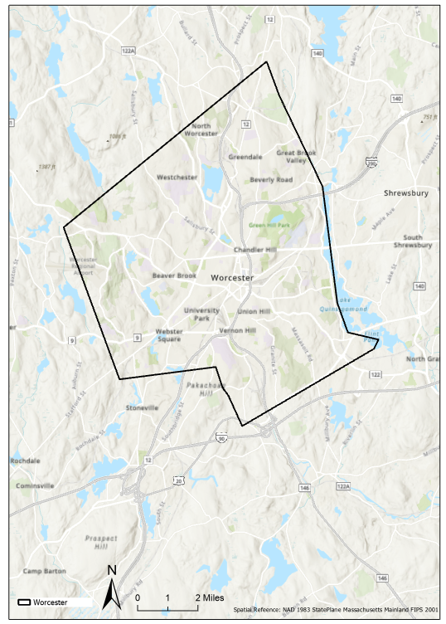

Map 1. Study Area (Worcester County, Massachusetts)

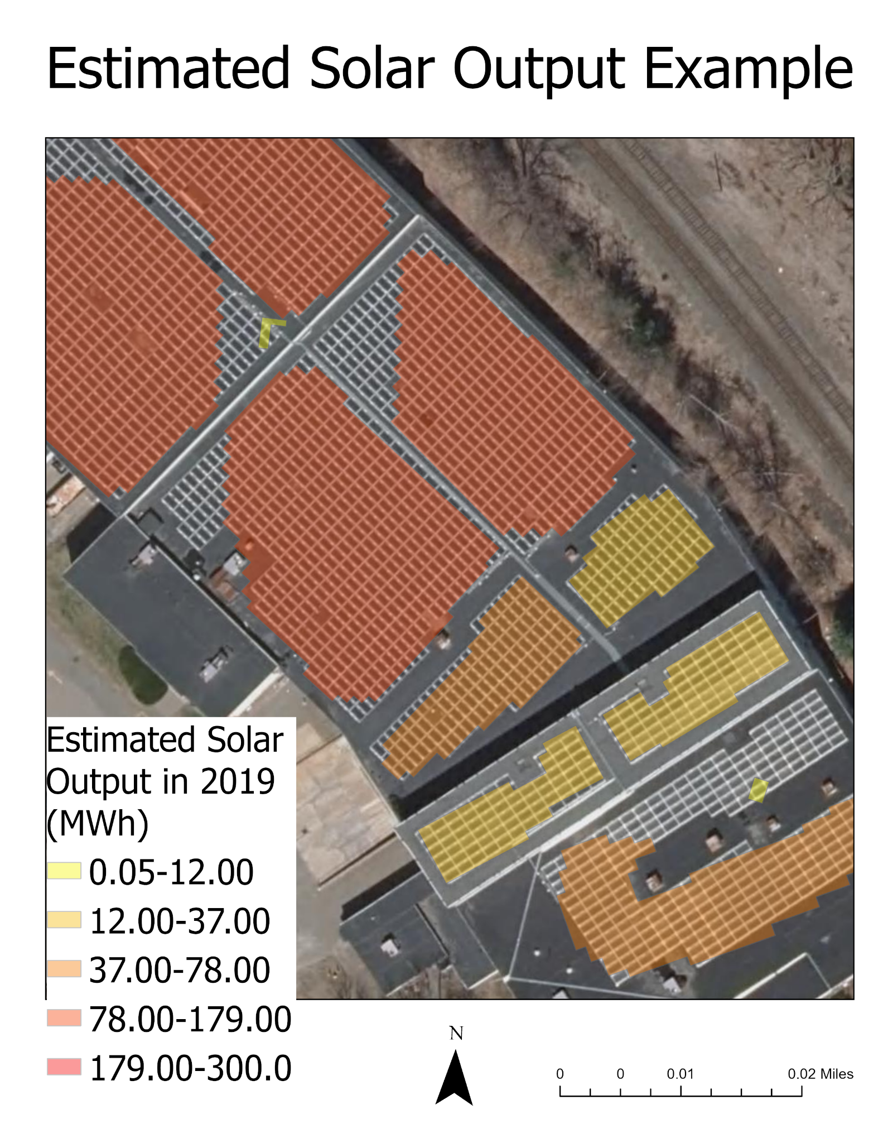

Map 2. Estimated Solar Output of auto-generated solar panel polygons in 2019, MWh

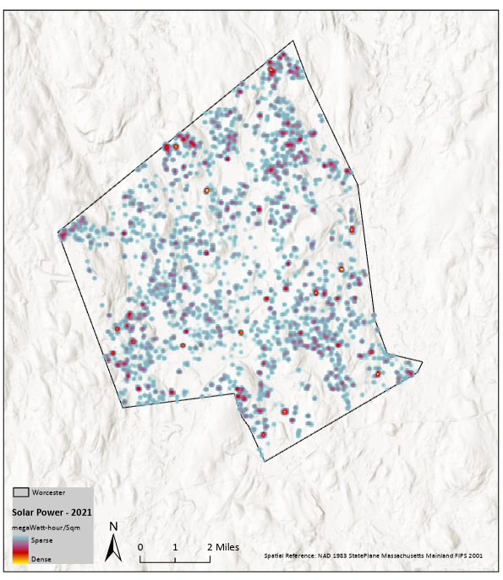

Map 3. Solar power generated from predicted solar panel polygons in 2021, MWh/Sqm

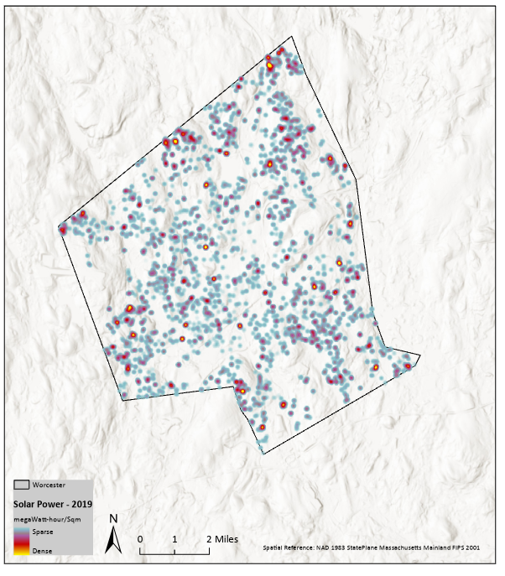

Map 4. Solar power generated from predicted solar panel polygons in 2019, MWh/Sqm

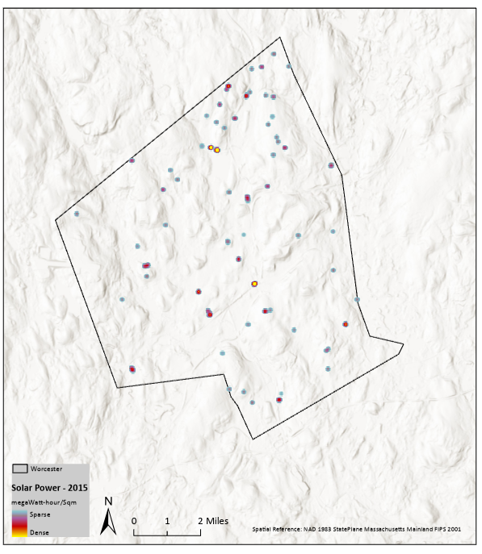

Map 5. Solar power generated from predicted solar panel polygons in 2015, MWh/Sqm

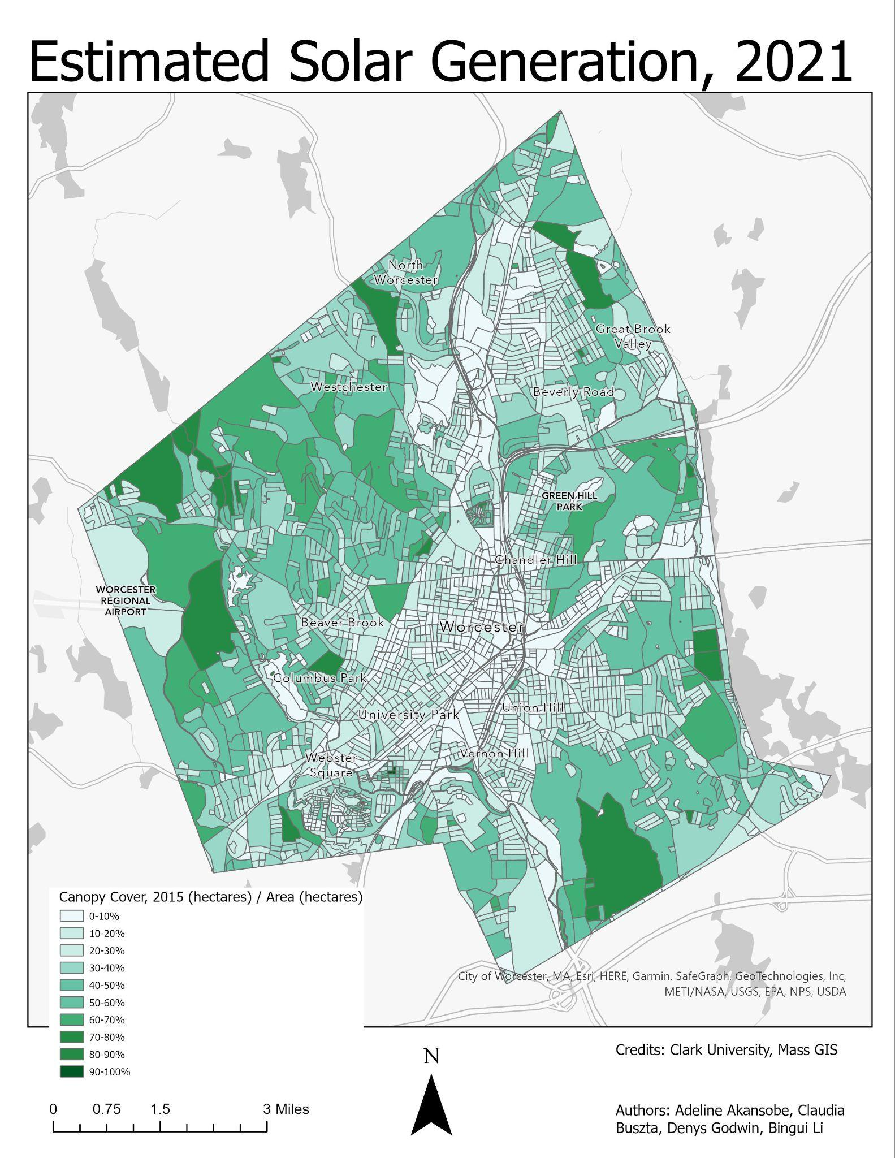

Map 6. Tree Canopy over Worcester, 2015

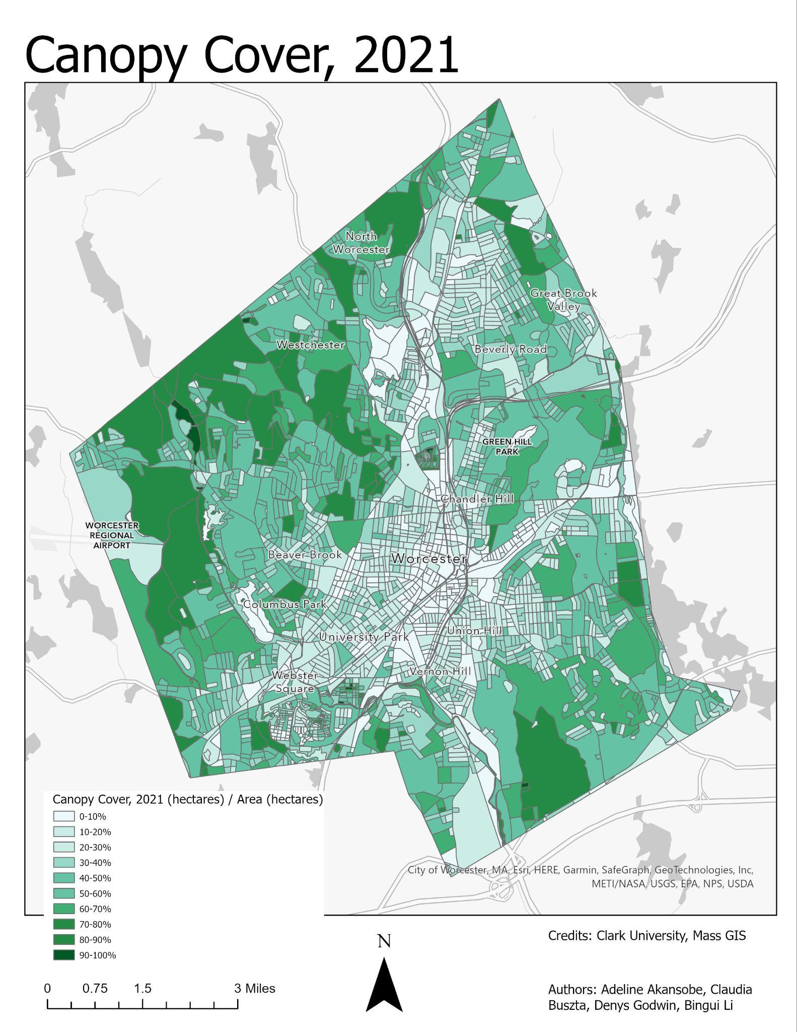Map 7. Tree Canopy over Worcester, 2021

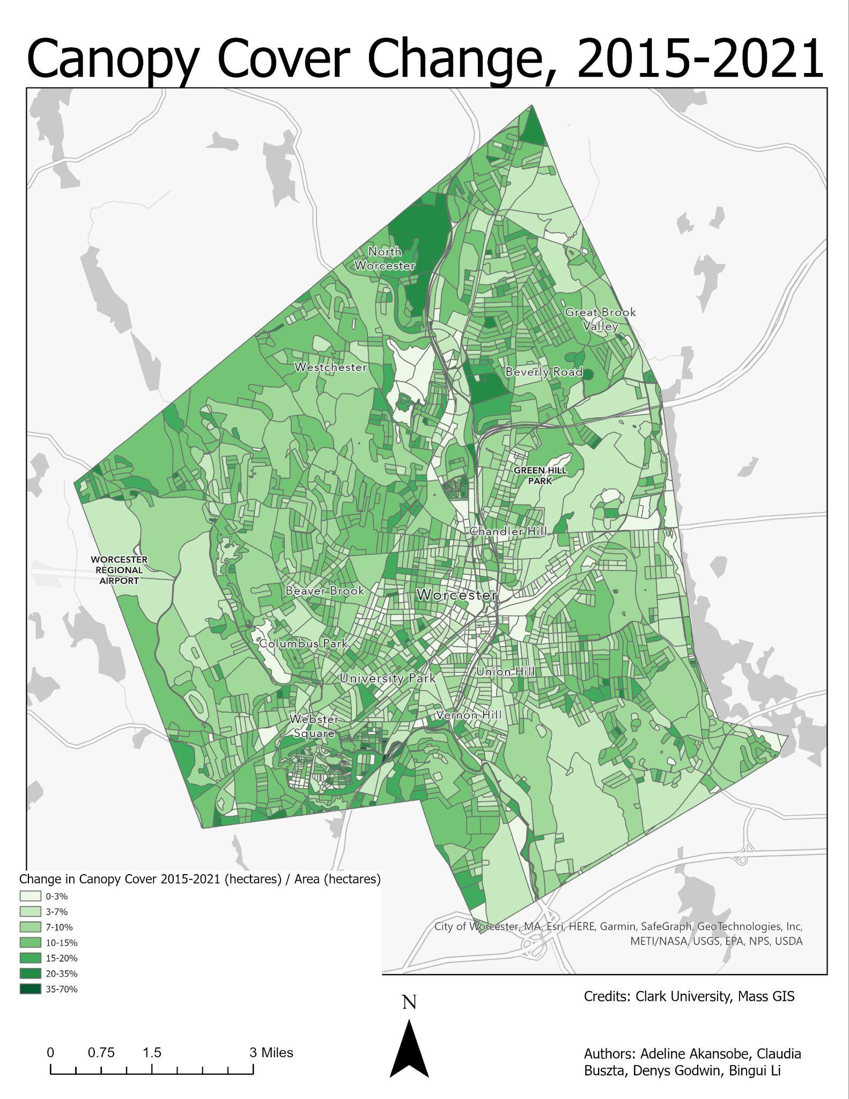Map 8. Change in tree canopy in Worcester, 2015-2021

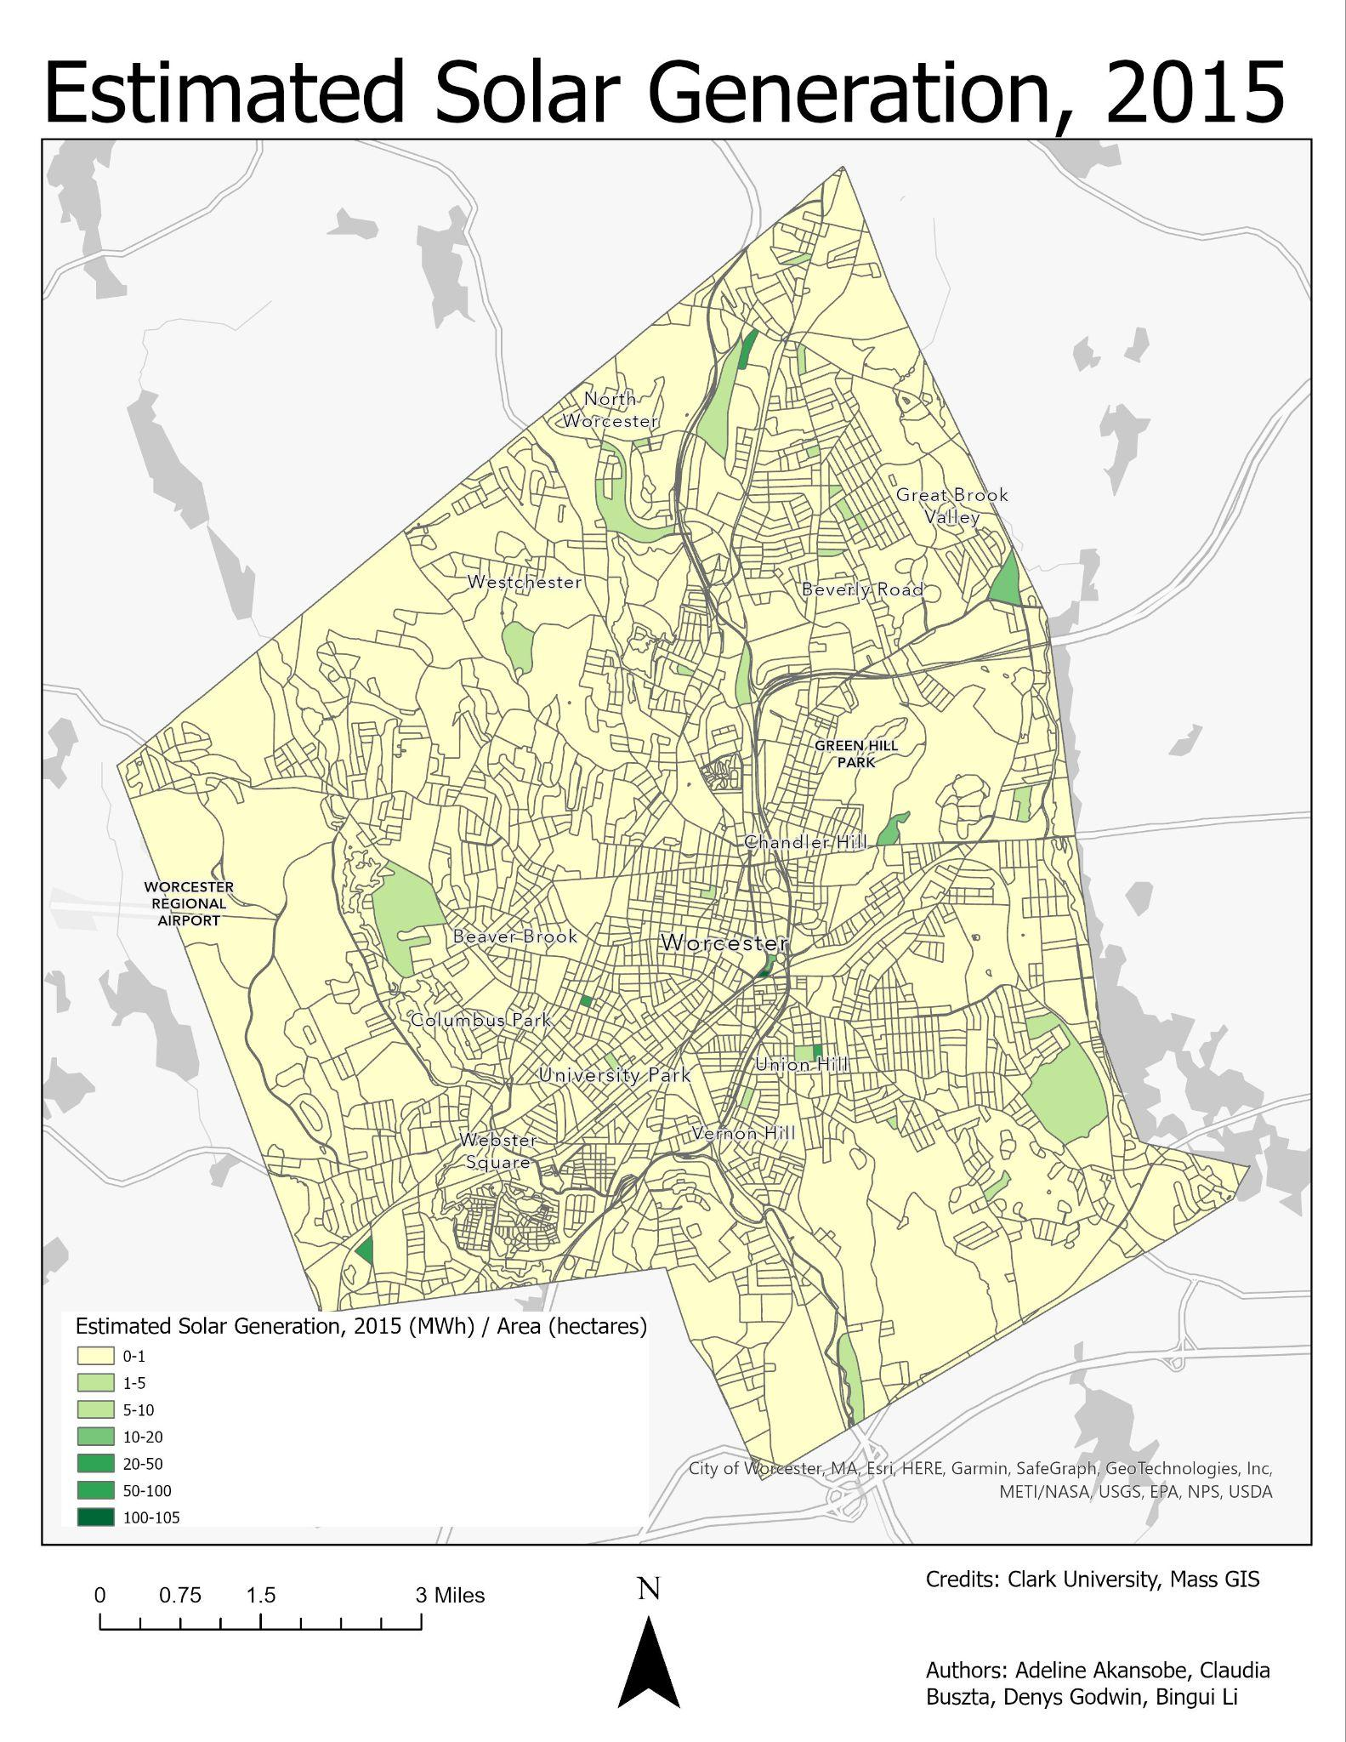

Map 9. Solar Power Generation in Worcester, 2015

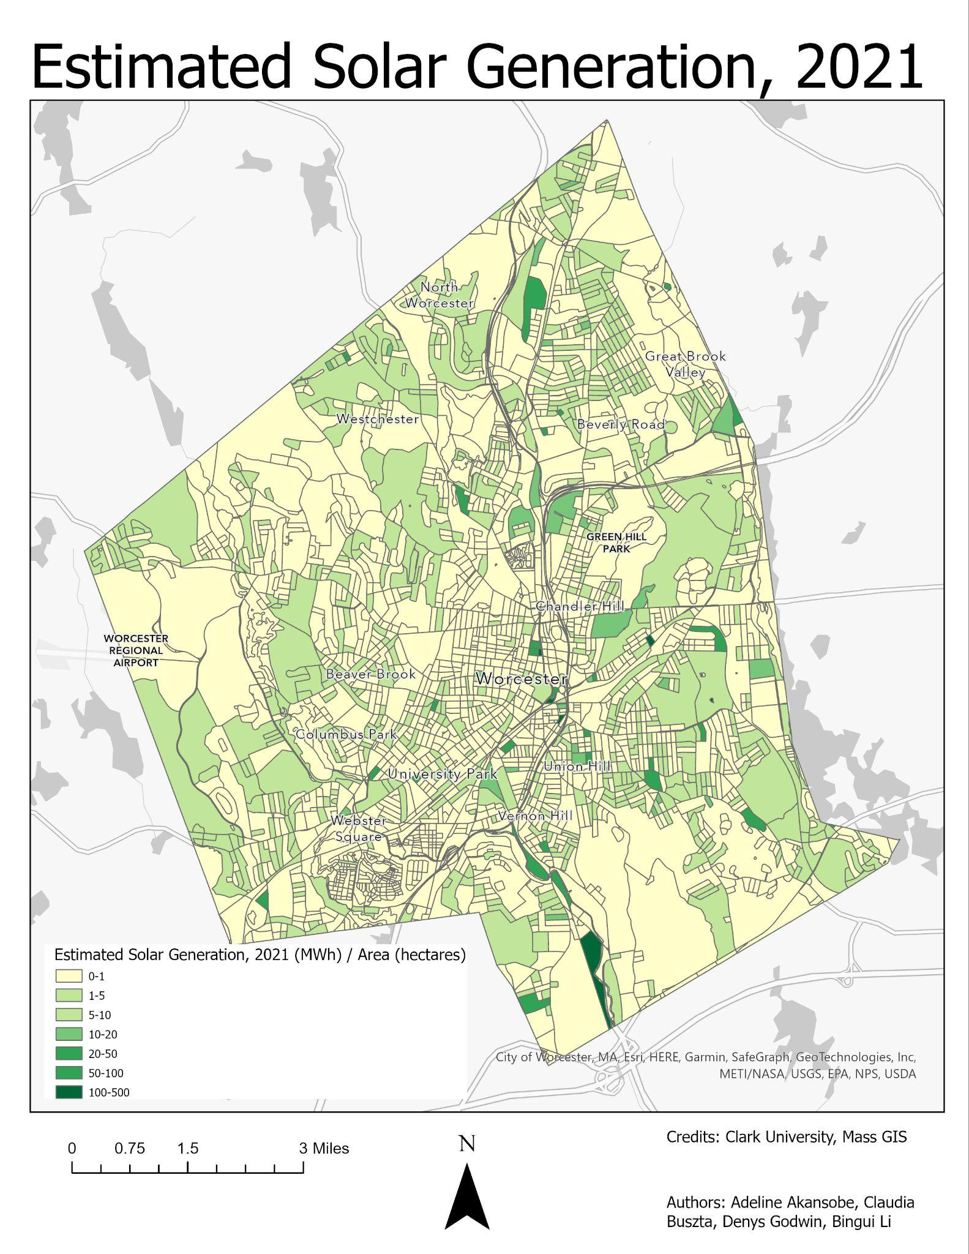

Map 10. Solar Power Generation in Worcester, 2021

# **Appendix B. Imagery, Figures and Graphs**

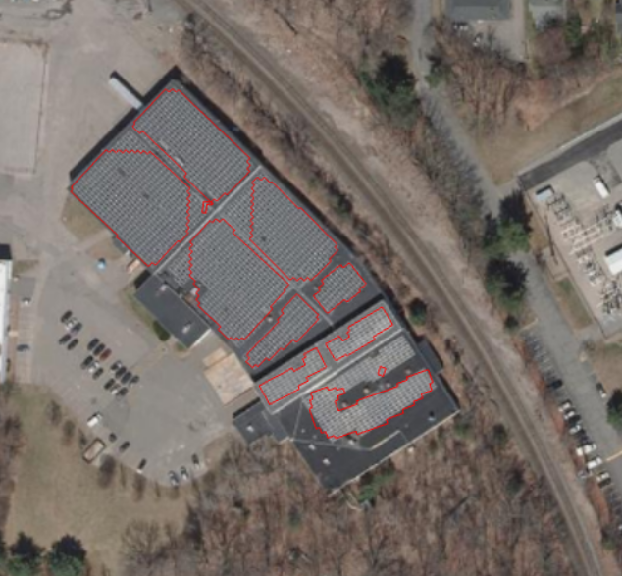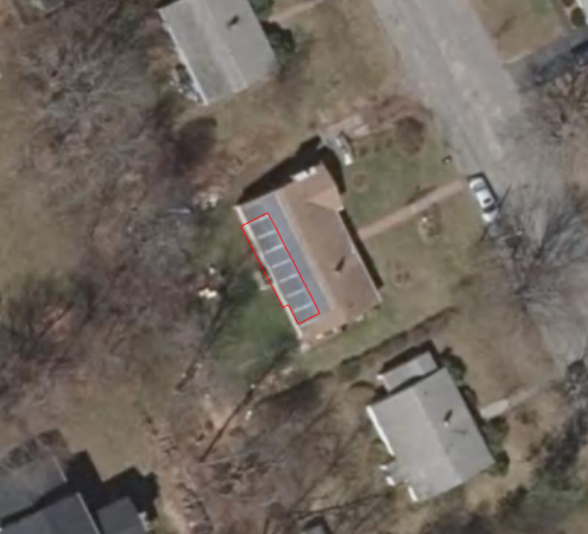

Fig 1. Example of automatically identified solar polygons from 2019, with borders in red over source imagery. The model tends to underestimate the size of correctly identified solar arrays.

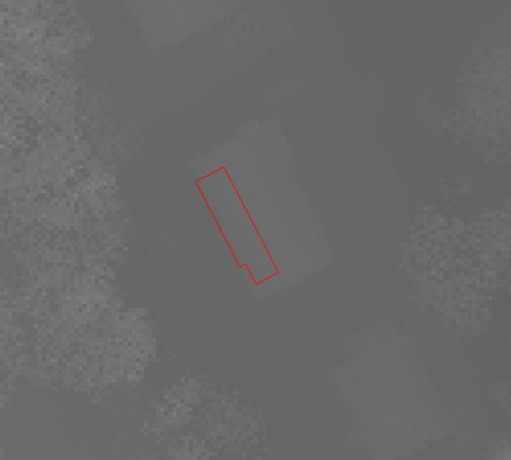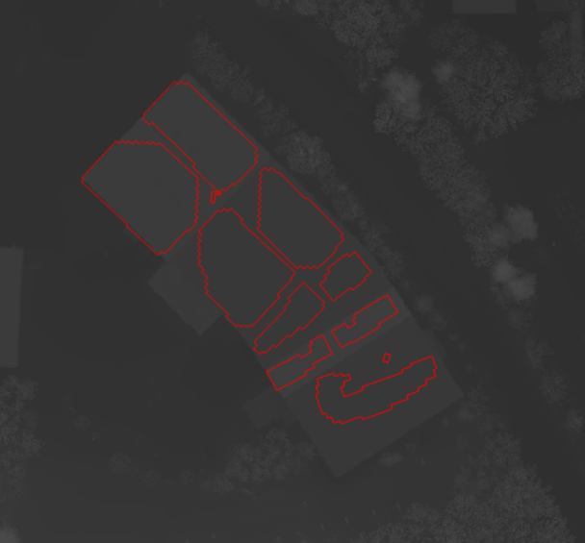

Fig 2. Example of 2019 solar polygons compared to LiDAR-derived 40cm DSM.

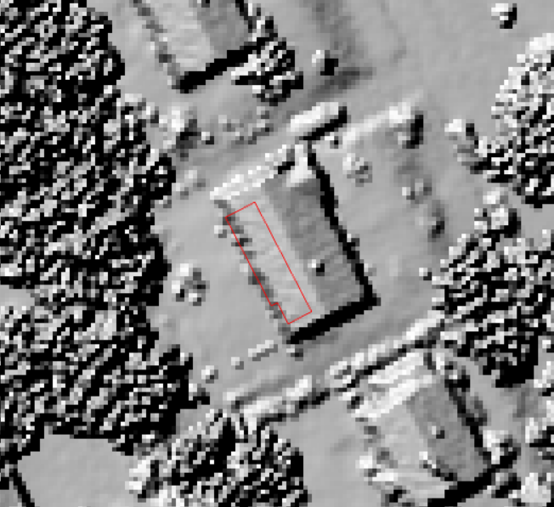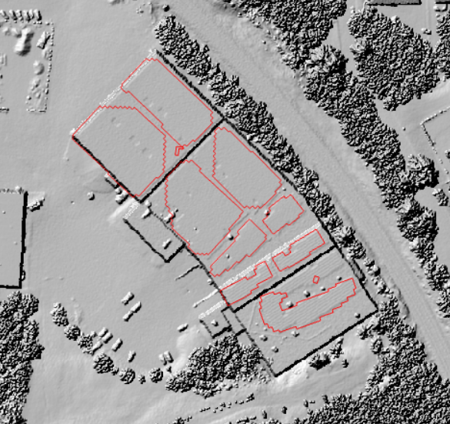

Fig 3. Example of 2019 solar polygons compared to hillshade of DSM for visualization purposes.

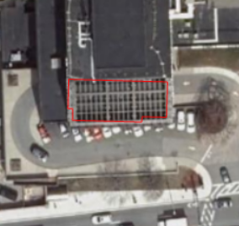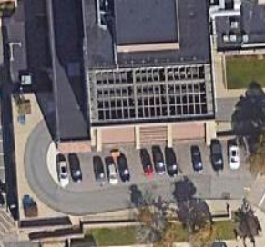

Fig. 4. ML-generated patch bounds misidentifies the UMass Memorial Medical Center skylight as solar (left). This is clearer in Google Maps imagery of the same location (right).

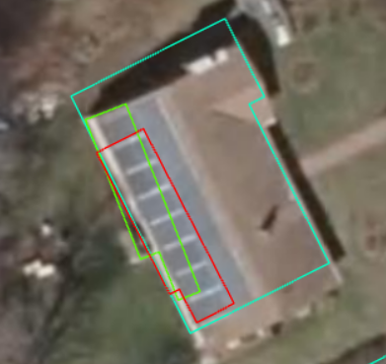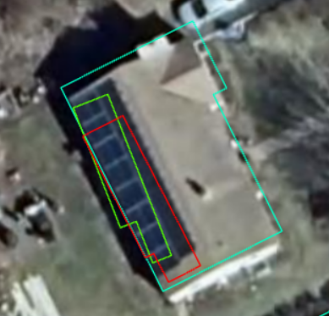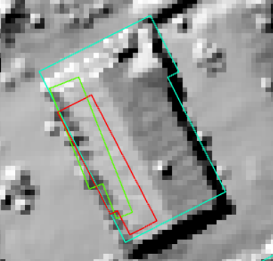

Fig 5. All images contain building footprint (blue), 2019 auto-generated solar patch (red), and 2021 auto-generated solar patch (green). Left image: 2019 orthophotos. Center image: 2021 orthophotos. Right image: hillshade derived from LiDAR.

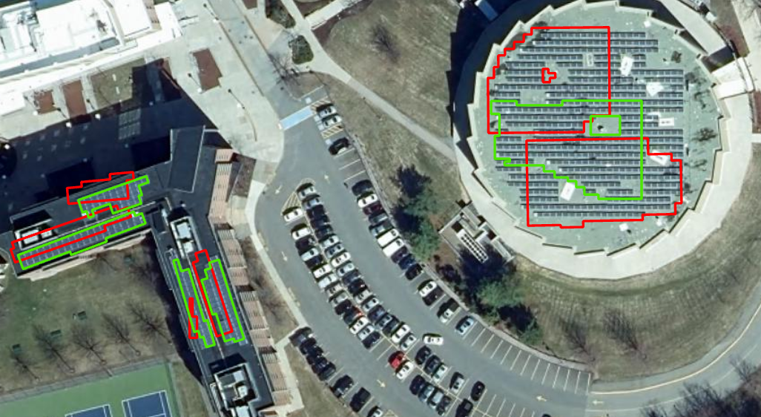

Fig 6: Irregularities in solar panel detection at Worcester State University. 2015 Auto-detected polygons (red) are larger and more numerous than 2021 auto-detected polygons (green) due to differences in image quality, nadir, and shadow aspect from year to year. This leads to errors such as a measured reduction in solar generation in this area where none such reduction exists.

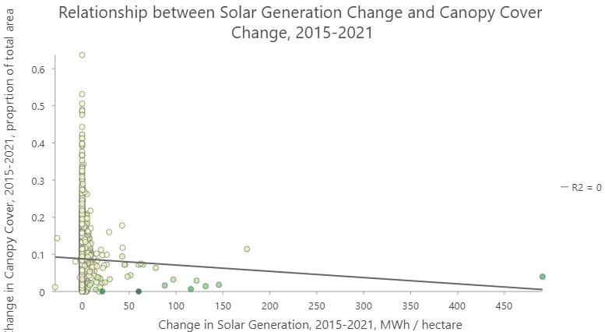

Fig 7. Relationship between solar generation change and canopy cover change, aggregated by census block

**References**

Gawley, D., & McKenzie, P. (2022). Investigating the suitability of GIS and remotely-sensed

datasets for photovoltaic modelling on building rooftops. Energy and Buildings, 265, 1-14. Article 112083. Advanced online publication. <https://doi.org/10.1016/j.enbuild.2022.112083>.

Massachusetts Executive Office of Energy and Environmental Affairs (EEA). (2023). *Tree Canopy 2016*  [Data set]. Massachusetts Executive Office of Energy and Environmental Affairs (EEA). <https://hub.arcgis.com/maps/Mass-EOEEA::tree-canopy-2016-1/explore?location=42.247829%2C-71.801058%2C15.16>

Mass.gov. (2023). *Understanding your utility bill*. Department of Public Utilities. https://www.mass.gov/info-details/understanding-your-utility-bill

MassGIS (Bureau of Geographic Information). (2023). *MassGIS Data: Building Structures (2-D)* [Data set]. Commonwealth of Massachusetts. <https://www.mass.gov/info-details/massgis-data-building-structures-2-d>

MassGIS (Bureau of Geographic Information). (2023). *MassGIS Data: 2021 Aerial Imagery*. [Data set]. Commonwealth of Massachusetts. <https://www.mass.gov/info-details/massgis-data-2021-aerial-imagery>

MassGIS (Bureau of Geographic Information). (2023). *MassGIS Data: 2019 Aerial Imagery*. [Data set]. Commonwealth of Massachusetts. <https://www.mass.gov/info-details/massgis-data-2019-aerial-imagery>

MassGIS (Bureau of Geographic Information). (2023). *MassGIS Data: 2014 Aerial Imagery*. [Data set]. Commonwealth of Massachusetts. [https://www.mass.gov/info-details/massgis-data-2014-aerial-imagery](https://www.mass.gov/info-details/massgis-data-2019-aerial-imagery)

Moulton, C. (2018, September 25). *A New Leaf*. The Worcester Telegram & Gazette. <https://www.telegram.com/story/news/local/worcester/2018/08/04/10-years-after-asian-longhorned-beetle-infestation-worcesters-urban-forest-blooms-with-diversity/6615978007/>

Schwan, H. (2023, Nov 2). *Take your project somewhere else: Resident opposition to Worcester developer.* Worcester Telegram & Gazette. https://www.telegram.com/story/news/2023/11/02/green-island-residents-angry-disappointed-over-proposed-development/71405962007/

Shivanshu, D. (2020). Solar technologies and their implementations: A review, Journal home page for Materials Today: Proceedings, Volume 28, Part 4, 2020, Pages 2137-2148, https://doi.org/10.1016/j.matpr.2020.04.134.

Tao, S., Rogan, J., Ye, S., & Geron, N. (2023). Mapping photovoltaic power stations and assessing their environmental impacts from multi-sensor datasets in Massachusetts, United States. Remote Sensing Applications: Society and Environment, 30, 100937.

US EPA. (2023). Green Power Equivalency calculator - calculations and references. https://www.epa.gov/green-power-markets/green-power-equivalency-calculator-calculations-and-references

USGS. (2023). *Central/Eastern Lidar Point Cloud*. [Data set]. United States government. <https://rockyweb.usgs.gov/vdelivery/Datasets/Staged/Elevation/LPC/Projects/MA_CentralEastern_2021_B21/MA_CentralEastern_1_2021/LAZ/>

Xia, Z., Li, Y., Chen, R., Sengupta, D., Guo, X., Xiong, B., & Niu, Y. (2022). Mapping the rapid development of photovoltaic power stations in northwestern China using remote sensing. Energy Reports, 8, 4117–4127. <https://doi.org/10.1016/j.egyr.2022.03.039>.